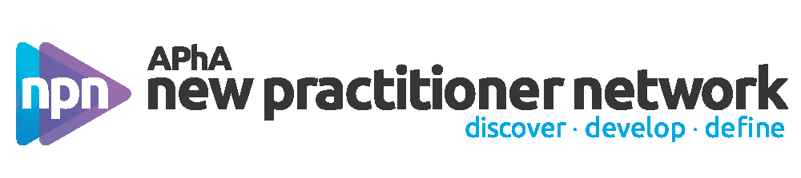
APhA New Practitioner Network
New Practitioner Advisory Committee

GENERAL INFORMATION AND ELIGIBILITY

The APhA New Practitioner Network (NPN) New Practitioner Advisory Committee (NPAC) is a nationally-appointed committee of five members comprising the following offices: Chair, Vice-Chair, and three (3) Members-at-large. APhA NPAC members serve a term of 1 year, with the exception of the Vice-Chair who serves a 2-year term. The outgoing APhA NPAC makes recommendations for appointees to the APhA Board of Trustees. The APhA Board of Trustees makes the final appointments to the APhA NPAC. The term of appointment is from the APhA2019 Annual Meeting to the APhA2020 Annual Meeting.

The efforts of the NPN NPAC support the mission and vision of the NPN:
Vision Statement: Discover. Develop. Define.
Mission Statement: Engage with new practitioners through life and career transitions by providing education, resources, and a community of support.

Any new practitioner member who has demonstrated leadership qualities within professional organizations and the pharmacy profession is eligible for appointment. All applicants will receive notification of the status of their application after the November APhA Board of Trustees meeting.

Serving as a member of the APhA NPAC is rewarding and satisfying, both professionally and personally. At times, serving as on the APhA NPAC may be a difficult and demanding job, but the position is meant to complement, not compete with, professional responsibilities.

All APhA NPAC members occasionally are required to attend meetings and conferences during the term of appointment. No monetary or material awards are provided to APhA NPAC Members.

APhA NPAC MEETING TIMELINE

Event | Event Date | Encouraged to Attend | Required to Attend
APhA2019 Annual Meeting & Expo | March 22-25, 2019 | Yes | —
APhA Academies Leadership Retreat | April 18-21, 2019 |  | Yes
APhA Day of NP LIFE | July 12-14, 2019 | — | Yes
APhA-ASP Midyear Regional Meetings | Oct-Nov 2019 | — | Yes
APhA2020 Annual Meeting & Expo | March 20-23, 2020 | — | Yes
Monthly Conference Calls | Monthly | — | Yes

Costs for travel and registration for required meetings is provided by APhA.

APhA NPAC CHAIR (1)

- Uphold the bylaws, vision, mission, goals, and objectives of APhA
- Represent the New Practitioner Network on behalf of its membership at-large
- Maintain regular contact with APhA staff and assist with NPN operations as appropriate
- Serve as Liaison to the APhA Board of Trustees and APhA-APPM/APhA-APRS Executive Committees
- Serve as Member-at-large on the APhA Strategic Directions Committee
- Attend the APhA Academies Leadership Retreat, presiding over all New Practitioner Network events and leading strategic planning
- Attend A Day of NP LIFE, presiding over all New Practitioner Network events
- Attend the APhA Annual Meeting, presiding over all New Practitioner Network events
- Preside over monthly conference calls of the New Practitioner Advisory Committee
- Participate in various communication efforts for the NPN and the Association, including social media and NP Engage
- Serve as a liaison to other pharmacy or health care organizations
- Develop and present the New Practitioner Network Annual Report to APhA Staff and the Board of Trustees
- Other duties as appropriate/assigned

APhA NPAC VICE-CHAIR (1)

- Uphold the bylaws, vision, mission, goals, and objectives of APhA
- Represent the New Practitioner Network on behalf of its membership-at-large
- Maintain regular contact with APhA staff and assist with NPN operations as appropriate
- Coordinate awards activities for the NPAC, including the Distinguished New Practitioner Award
- Attend the APhA Academies Leadership Retreat and participate in strategic planning
- Attend and participate in A Day of NP LIFE
- Attend the APhA Annual Meeting and all New Practitioner Network events
- Participate in monthly conference calls of the New Practitioner Advisory Committee
- Preside over monthly Standing Committee Chair conference calls
- Participate in various communication efforts for the NPN and the Association, including social media and NP Engage
- Act as Chair in the event of the Chair’s absence
- Other duties as appropriate/assigned

APhA NPAC MEMBER-AT-LARGE (3)

- Uphold the bylaws, vision, mission, goals, and objectives of APhA
- Represent the New Practitioner Network on behalf of its membership-at-large
- Maintain regular contact with APhA staff and assist with NPN operations as appropriate
- Serve as Liaison to one of three APhA New Practitioner Network Standing Committees (Communications, Education, Member Engagement)
- Attend the APhA Academies Leadership Retreat and participate in strategic planning
- Attend and participate in A Day of NP LIFE
- Attend the APhA Annual Meeting and all New Practitioner Network events
- Participate in monthly conference calls of the New Practitioner Advisory Committee
- Review position description of respective Standing Committee annually, updating as appropriate
- Attend monthly Standing Committee conference calls
- Participate in various communication efforts for the NPN and the Association, including social media and NP Engage
- Other duties as appropriate/assigned

